Counting Cubes Task

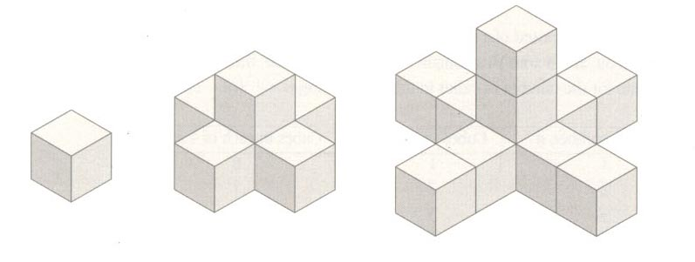
Building 3
Building 2
Building 1

  - Describe a pattern you see in the cube buildings.

  - Use your pattern to write an expression for the number of cubes in the nth building.

  - Use your expression to find the number of cubes in the 5th building. Check your results by constructing the 5th building and counting the cubes.

  - Look for a different pattern in the buildings. Describe the pattern and use it to write a different expression for the number of cubes in the nth building.

Adapted from “Counting Cubes”, Lappan, Fey, Fitzgerald, Friel, & Phillips (2004). Connected MathematicsTM, Say it with symbols: Algebraic reasoning [Teacher’s Edition]. Glenview, IL: Pearson Prentice Hall. © Michigan State University

